Lab No: 7 Form Processing using Django – Part I

Name: Ketan Goud
Reg No: 220905260
Section: D D2
Roll No: 39

1) Develop a web application using Django framework to demonstrate the transfer of multiple parameters between web pages. User should be presented with a dropdown list containing car manufacturers, a text box which takes model name of the manufacturer and a submit button. On submitting the web page, the user is forwarded to a new page. This new page should display the selected car manufacturer name and the model name.

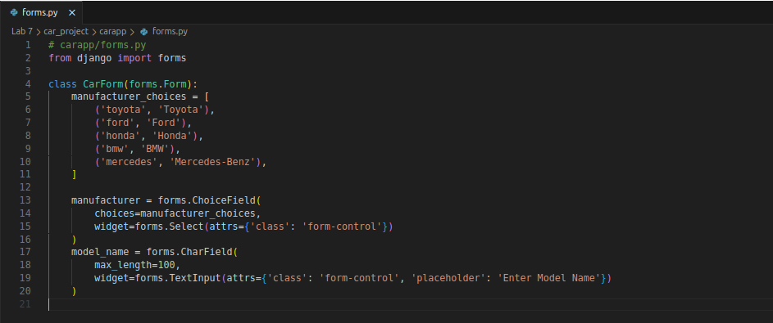
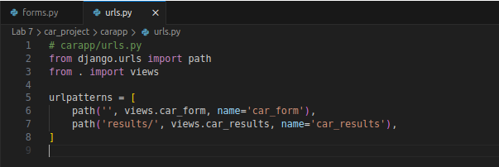
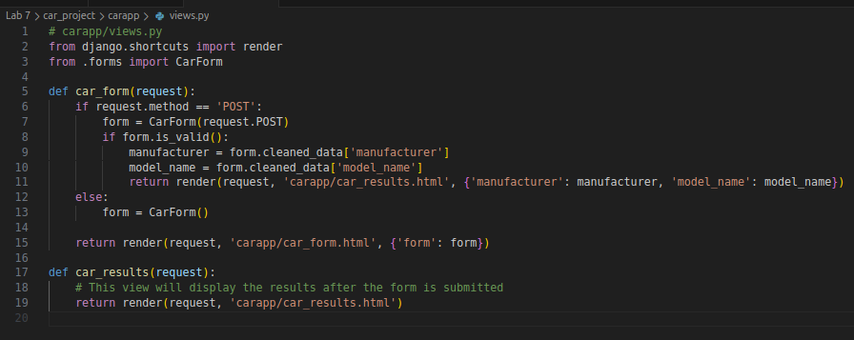
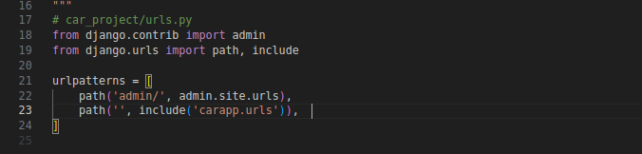
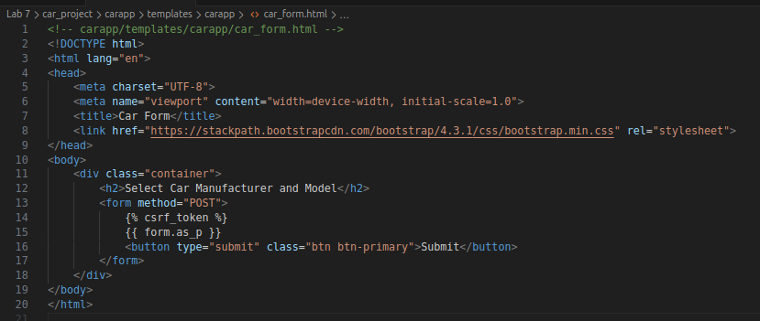
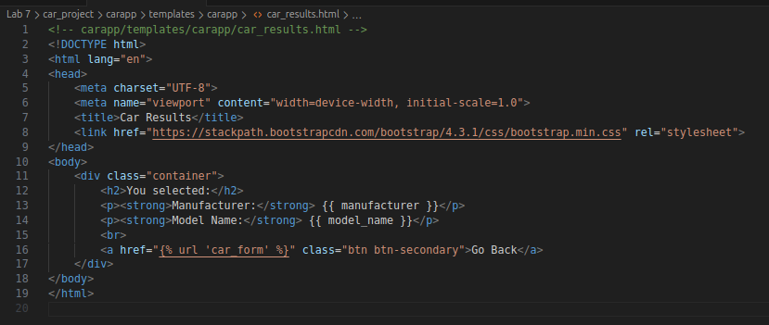

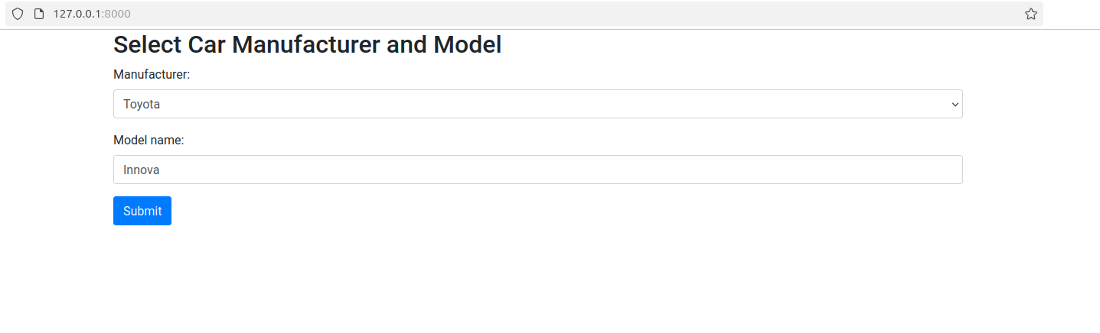
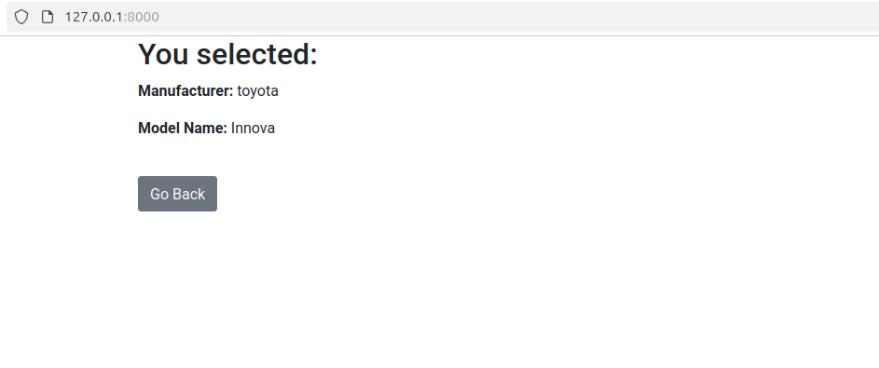

2) Create a page firstPage.html with two TextBoxes [Name, Roll], DropDownList [Subjects], and a button. Create another page secondPage.html with a label and a button. When the user clicks the button in first Page, he should be sent to the second page and display the contents

